Name: __________________ Class: _______ Date: __________
Star Test (ELL)
Part 1: Label each star.

Color
-Blue-White
-Orange or Yellow or White
-Red
Temperature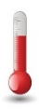
-Medium
-Cooler
-Hottest
Size
-Small
-Biggest
-Medium
Luminosity
-High
-Low
-Medium

Part 2: Identify each picture. Use the word box.
Galaxy Star Constellation

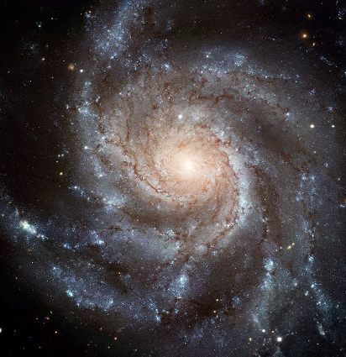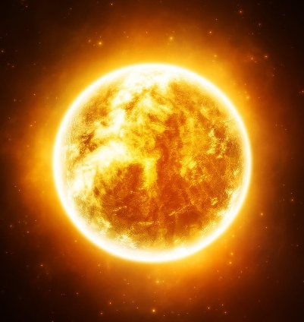

1._____________ 2.__________________ 3.__________________

Part 3: Label each definition. Use the word box.
Luminosity Constellation Star Galaxy

_______________ 1. Large ball of gas with a hot core (center) that generates (creates) energy using nuclear fusion.
_______________ 2. The true brightness of a star.
_______________ 3. A huge collection (group) of stars.
_______________ 4. A pattern of stars in the sky.

