Name: ________________________ Class: __________ Date: __________

Classify (Label) Stars

Separate by temperature , color, and mass (size).

Color the stars the correct color.

Orange/Yellow/**White**

Medium temperature 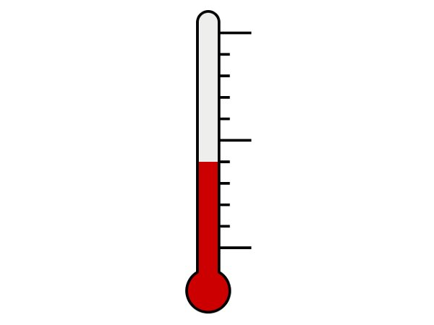

Size: Medium

Medium luminosity

Red

Cooler 

Size: Small

Low luminosity

Blue-**White**

Hottest 

Biggest

High luminosity