Name: ______________________ Class: ________ Date:________
Stars
Star | Definition:  Large ball of gas 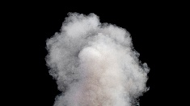  with a hot core (center) 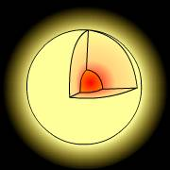  that generates (creates) energy using  nuclear fusion | You write the definition:  (the underlined words are important) | Draw a Picture:
Luminosity | Definition:  The true brightness of a star  Brightest (high luminosity)  Dimmest (low luminosity) | You write the definition:  (the underlined words are important) | Draw a Picture:

