Name: _____________ Class: _____ Date: _________

The Planets - Test (ESL)

Section 1: Name each planet.

Jupiter Uranus Venus Earth
Mars Saturn Mercury Neptune

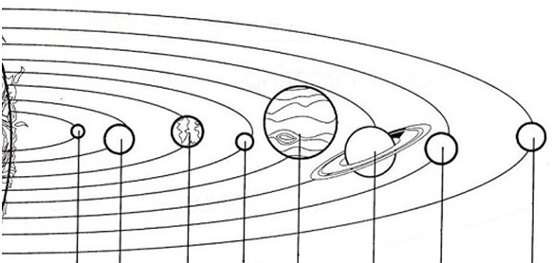

Section 2: Write the planets in the correct column, rocky or gas.
(Jupiter, Uranus, Venus, Earth, Mars, Saturn, Mercury, Neptune)
Rocky Planets | Gas Planets

Section 3: Label with rock or ice 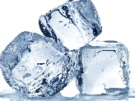.
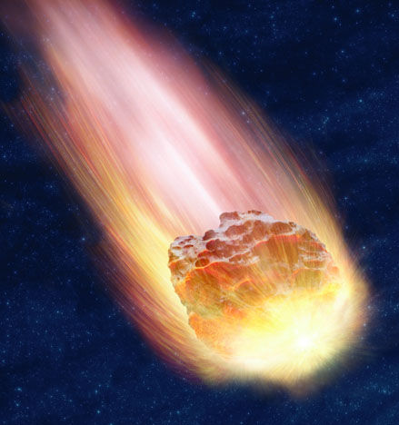 Comet: made of _________________. (rock/ice)
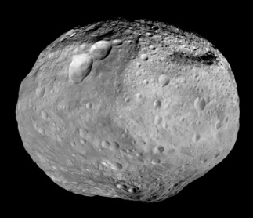 Asteroid: made of _________________. (rock/ice)
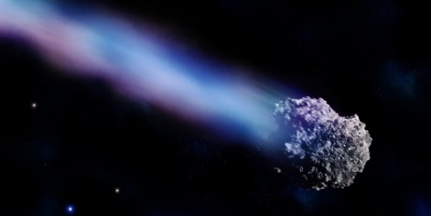 Meteor: made of _________________. (rock/ice)

