Name: ______________________ Class: ________ Date: _________
Carbon-Oxygen Cycle (ELL)
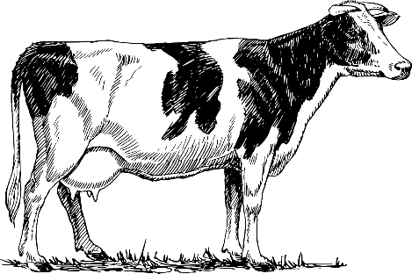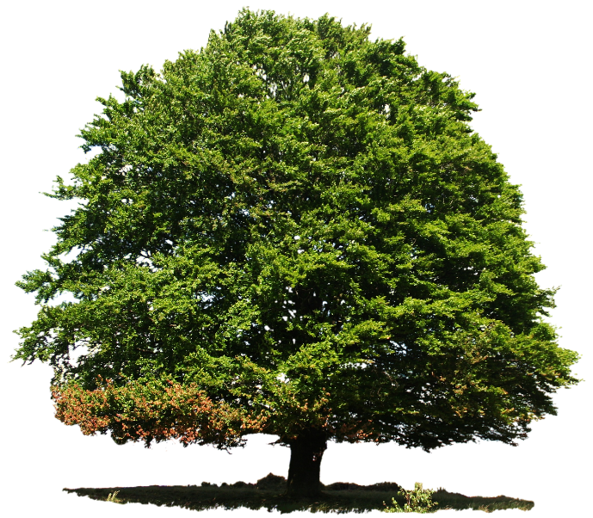
O₂
O₂
CO₂
CO₂
CO₂: _____________ O₂: __________________
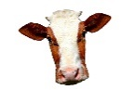
takes in ______________ → Respiration → releases _______________
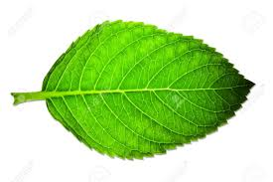
takes in ____________ → Photosynthesis → releases _____________
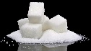
_______________: plants using light energy to make sugars (glucose) from CO₂ and water.
_______________: organisms use Oxygen to release energy from sugars (glucose) and release CO₂

How do plants and Animals use glucose?

Plants use sugars (glucose) for ____________ and _____________.
Animals use sugars (glucose) for __________ and _____________.

